International NGO Funding Benchmark Dashboard (2022–2024)
1. Introduction
International non-governmental organizations (NGOs) play a critical role in addressing humanitarian crises, development challenges, and global poverty. Large NGOs operate complex funding structures involving both public and private donors while managing large programmatic expenditures across multiple countries.
This project develops a Power BI benchmarking dashboard that compares the financial structure and funding patterns of major international NGOs. The dashboard focuses on four organizations:
- UNICEF
- World Vision International
- International Federation of Red Cross and Red Crescent Societies (IFRC)
- Save the Children
The objective is to demonstrate how business intelligence tools can be used to analyze funding patterns, financial scale, and program efficiency across organizations.
The dashboard visualizes income, expenditure, funding mix, and trends over time to support data-driven insights into NGO operations.

2. Data Sources
The dataset was constructed using publicly available financial information extracted from organizational annual reports:
Organization | Source
UNICEF | UNICEF Annual Report 2024
IFRC | IFRC Annual Report 2024
World Vision International | World Vision Global Annual Report 2024
Save the Children | Save the Children Annual Report 2024
Two datasets were prepared for the analysis:
Benchmark Dataset
This dataset contains financial metrics for each NGO including:
- Total income
- Total expenditure
- Public funding
- Private funding
- Program spending
- Organizational source reference
Trend Dataset
This dataset includes historical financial data for:
- Total income
- Total expenditure
- Year (2022–2024)
The separation of datasets enables both cross-sectional comparison and time-series analysis.

3. Methodology
The dashboard was built using Microsoft Power BI Desktop.
The analysis includes the following calculated metrics:
Total Income
Sum of reported revenues for each organization.
Total Expenditure
Total operational spending reported in annual reports.
Operating Balance
Calculated as:
Operating Balance = Total Income − Total Expenditure
This metric indicates the financial surplus or deficit for the organization.
Program Spending Ratio
Calculated as:
Program Spending Ratio = Program Spend / Total Expenditure
This ratio provides insight into how much of total spending is allocated to programmatic activities rather than administrative costs.
Funding Mix
Funding is divided into:
- Private funding (donations, foundations, individuals)
- Public funding (government or institutional donors)
This allows evaluation of organizational funding dependence.

4. Dashboard Structure
The Power BI dashboard integrates several visual components including
key financial indicators, comparative funding analysis, and trend
visualizations.
Figure 1: NGO Funding Benchmark Dashboard
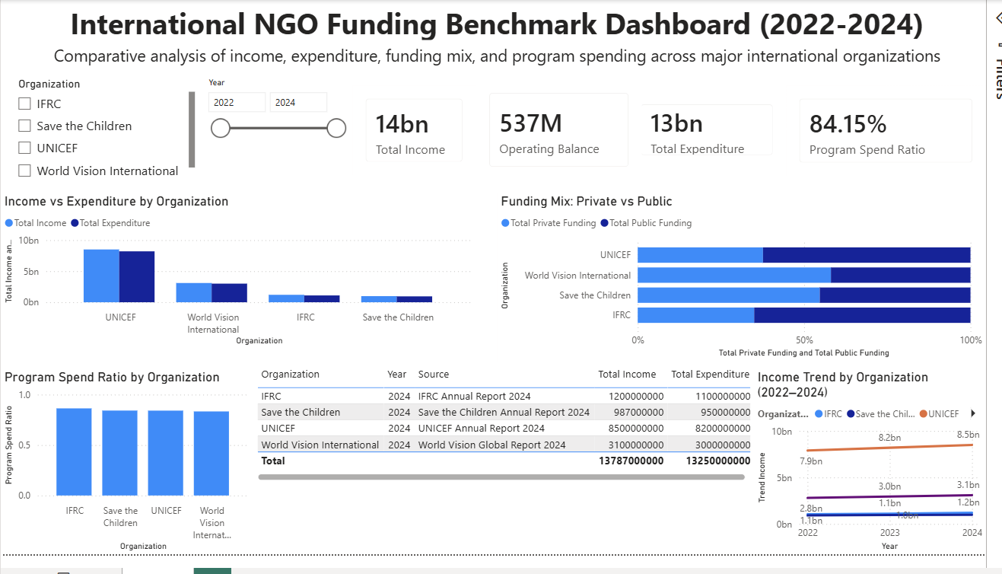
The Power BI dashboard consists of several visual components.
KPI Cards
The dashboard presents four key financial indicators:
- Total Income
- Operating Balance
- Total Expenditure
- Program Spending Ratio
These provide a high-level overview of financial scale and operational efficiency.
Example summary metrics:
Metric | Value
Total Income | 14 billion USD
Total Expenditure | 13 billion USD
Operating Balance | 537 million USD
Program Spending Ratio | 84.15%
These indicators summarize the overall funding scale and operational structure across the analyzed NGOs.

5. Comparative Financial Analysis
Figure 3: Income vs Expenditure Comparison
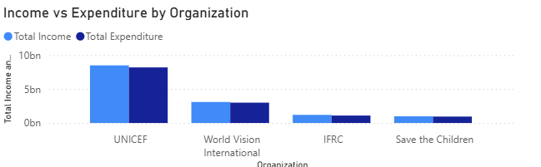
Income vs Expenditure
The Income vs Expenditure chart compares the financial scale of each organization.
Key observations:
- UNICEF has the largest financial scale among the analyzed organizations.
- World Vision International is the second-largest in terms of total revenue.
- IFRC and Save the Children operate at smaller but still significant funding levels.
This comparison highlights differences in organizational scale and operational budgets.

6. Funding Structure
The Funding Mix visualization analyzes the relative dependence on private and public funding sources.
Key findings:
- UNICEF receives a large portion of its funding from government and institutional donors.
- World Vision International shows a relatively higher share of private funding, reflecting strong individual sponsorship programs.
- Save the Children and IFRC maintain a more balanced mix of funding sources.
Understanding funding composition is important because funding diversity improves financial resilience.

7. Program Spending Efficiency
The Program Spending Ratio chart measures the share of total expenditure allocated directly to programmatic activities.
Key insight:
- All analyzed organizations maintain high program spending ratios (above ~80%), indicating that the majority of expenditures are directed toward mission-related programs.
High program spending ratios are often used by donors and evaluators as indicators of organizational efficiency and accountability.

8. Financial Trends (2022–2024)
The income trend chart visualizes the evolution of financial resources
across the analyzed organizations.
Figure 2: Income Trend Visualization
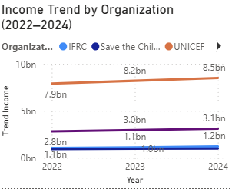
The Income Trend chart shows revenue changes over time.
Example trend for UNICEF:
Year | Income
2022 | 7.9B
2023 | 8.2B
2024 | 8.5B
This suggests moderate but consistent financial growth over the observed period.
Trend analysis helps identify:
- funding growth
- stability of financial flows
- potential vulnerability to funding shocks

9. Key Insights
Several insights emerge from the dashboard:
- UNICEF operates at the largest financial scale, reflecting its role as a major global multilateral organization.
- Funding sources vary significantly across organizations, with some relying more heavily on government funding and others on private donors.
- Program spending ratios across organizations are relatively high, indicating that most financial resources are directed toward operational programs.
- Revenue trends show gradual growth between 2022 and 2024, suggesting relative financial stability among the analyzed organizations.

10. Limitations
Several limitations should be acknowledged:
- Financial reporting structures vary between organizations.
- Currency conversions and reporting standards may differ.
- The dataset uses simplified aggregated values for visualization purposes.
Therefore, the dashboard should be interpreted as a comparative analytical illustration rather than a precise accounting analysis.

11. Conclusion
By combining financial datasets with interactive visualizations, the dashboard enables users to:
- compare organizational funding scale
- analyze funding structure
- assess program spending efficiency
- track financial trends over time
Such dashboards can support policy analysis, donor decision-making, and organizational benchmarking in the international development sector.

12. Tools Used
- Microsoft Power BI Desktop
- Excel / CSV data preparation
- Public NGO annual reports

